**DESIGNING A RESUME /CV USING CANVA**

Project report template:

INTRODUCTION

* 1. Over view:

A graphic design CV is a written document that showcases your qualifications for the role you're applying for, including skills, experience and certifications. Regularly update and edit your CV to meet the specific requirements of the company or job. Similar to a resume, you may use a graphic design CV to obtain an interview opportunity. Graphic design CVs typically highlight personal qualities and experience outside of a career, like hobbies or interests.

* 1. PURPOSE:

A graphic design CV is important because it's an effective way to increase your chances of getting an interview. Some employers may require a CV to better understand a candidate's expertise or accomplishments and to closely assess the skills they can bring to the position. A graphic design CV can make you a more marketable candidate and provide employers with a general idea of both your personal and professional lives. A polished graphic design CV is also important for job candidates because of these additional reasons:

* **Showcase your abilities:** With a more detailed design, a CV can more effectively highlight your talents, skills and expertise.
* **Reuse and easily update:** You can easily update and reuse your CV to match the requirements and preferences of different job descriptions for each role.
* **Obtain additional interviews:** A great CV that impresses hiring managers can lead them to invite you to interviews to expand more on your experience and skills.
* **Demonstrate a wide variety of skills:** A graphic design CV demonstrates your versatility as a designer and shows you can use your skills to meet the needs of various clients or projects.

2. PROBLEM DEFINITION & DESIGNING THINKING:

2.1 Empathy Map:

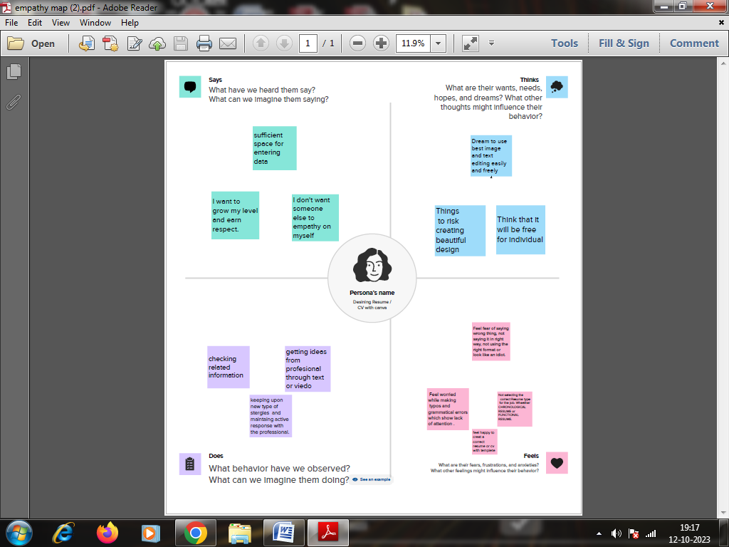

* 1. Ideation & Brainstorming:

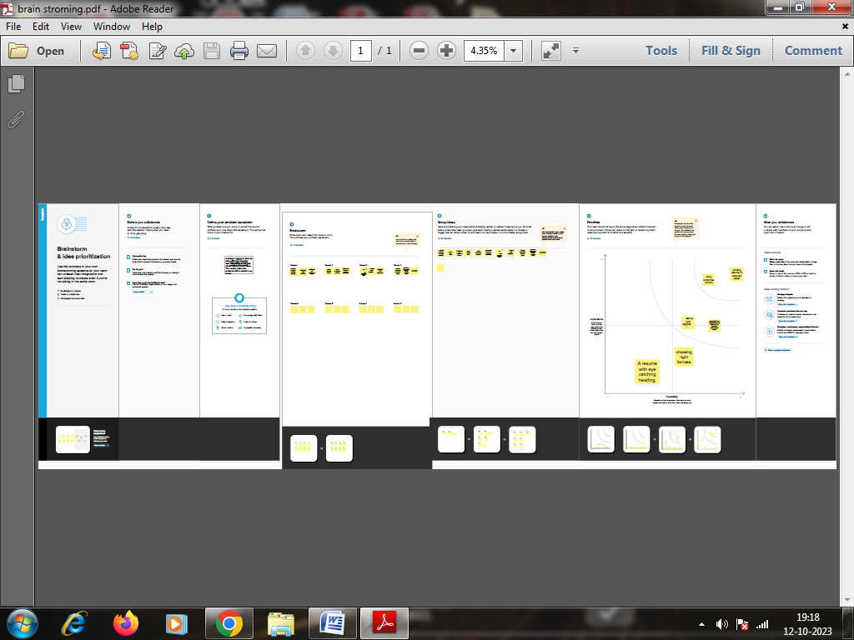

1. RESULT:

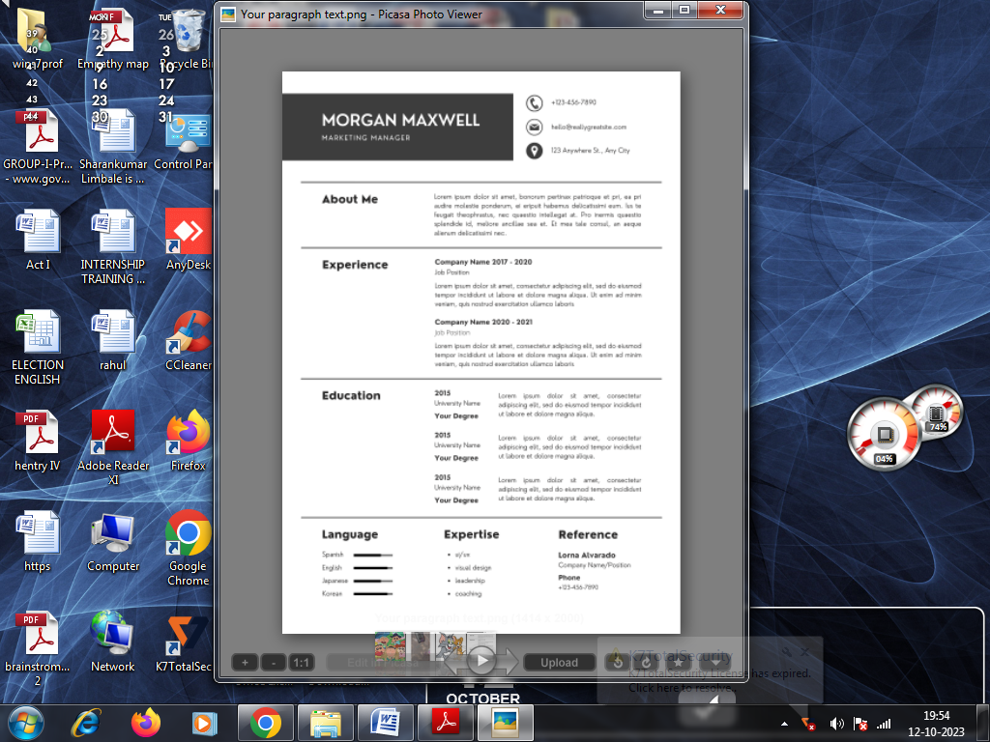

1. ADVANTAGES AND DISADVANTAGES:

* It makes it easy for an applicant to emphasise the skills and capabilities they have that are actually relevant to a specific role. Because the general format of a CV is one that employers are familiar with, it is easy for them to look for the required skillset in a candidate. In other applications, that might take a lot more effort and time
* It is possible to get an idea of someone’s personality from a CV.
* Qualifications like grades and schooling are given excessive importance. This enables discrimination based on where people went to university etc, qualities that can also be related to different economic backgrounds.
* CVs do not give any real proof of the candidate’s personality. A factor that is equally as important as capability and skills for a job is their personality and proof of their compatibility with the company they’re applying for, yet this cannot be determined from a CV beyond generic blanket statements.

1. APPLICATION:

A graphic design CV is a written document that showcases your qualifications for the role you're applying for, including skills, experience and certifications. Regularly update and edit your CV to meet the specific requirements of the company or job.

1. CONCLUSION:

Through this project we learnt to create any types of resume with canva. This project is useful to us to give a good performance in interviews.